Dinesh Shiwakoti
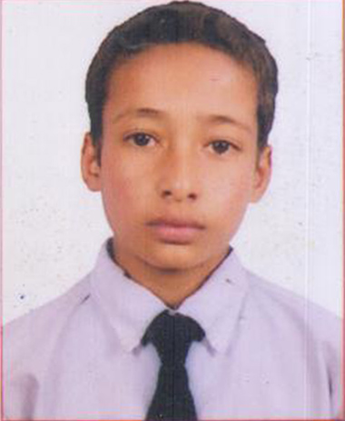
Dinesh Shivakoti is a regular student of grade 9 in Shree kalinaag higher secondary School.He lives in Sunkhani. He is a very hard working student with a good education skill. In the district level examination, he succeded to score 95% and became top among his class mates. Not only in the studies but dinesh is also very good in the extra activities held in the school such as sports, quiz programs, and other compititions.
Dinesh is from a poor farmer’s family living with his 4 siblings. He lost his mother when he was very small. Since then his father is looking after him and his family. His father, who is hardworking farmer, earning 20000 Rs annually, does every possible activities to feed his family including 5 children.
Dinesh is very obeident to his parents. He helps his father in his works and gives his best in supporting his father. His father’s monthly income is not sufficient for his family. it is very hard for them to manage all sort of necessary things such as food, shelter, education and all with this few income. Dinesh also works as a part time worker in order to support his family.
Everyday dinesh does all his household works and walks about 2KM on hill to reach his school. Though the path is difficult and his economic status is not high, it doesnot demotivate him to leave his studies. Gaining lots of knowledge and education, dinesh wants to be a civil engineer and serve the nation.

